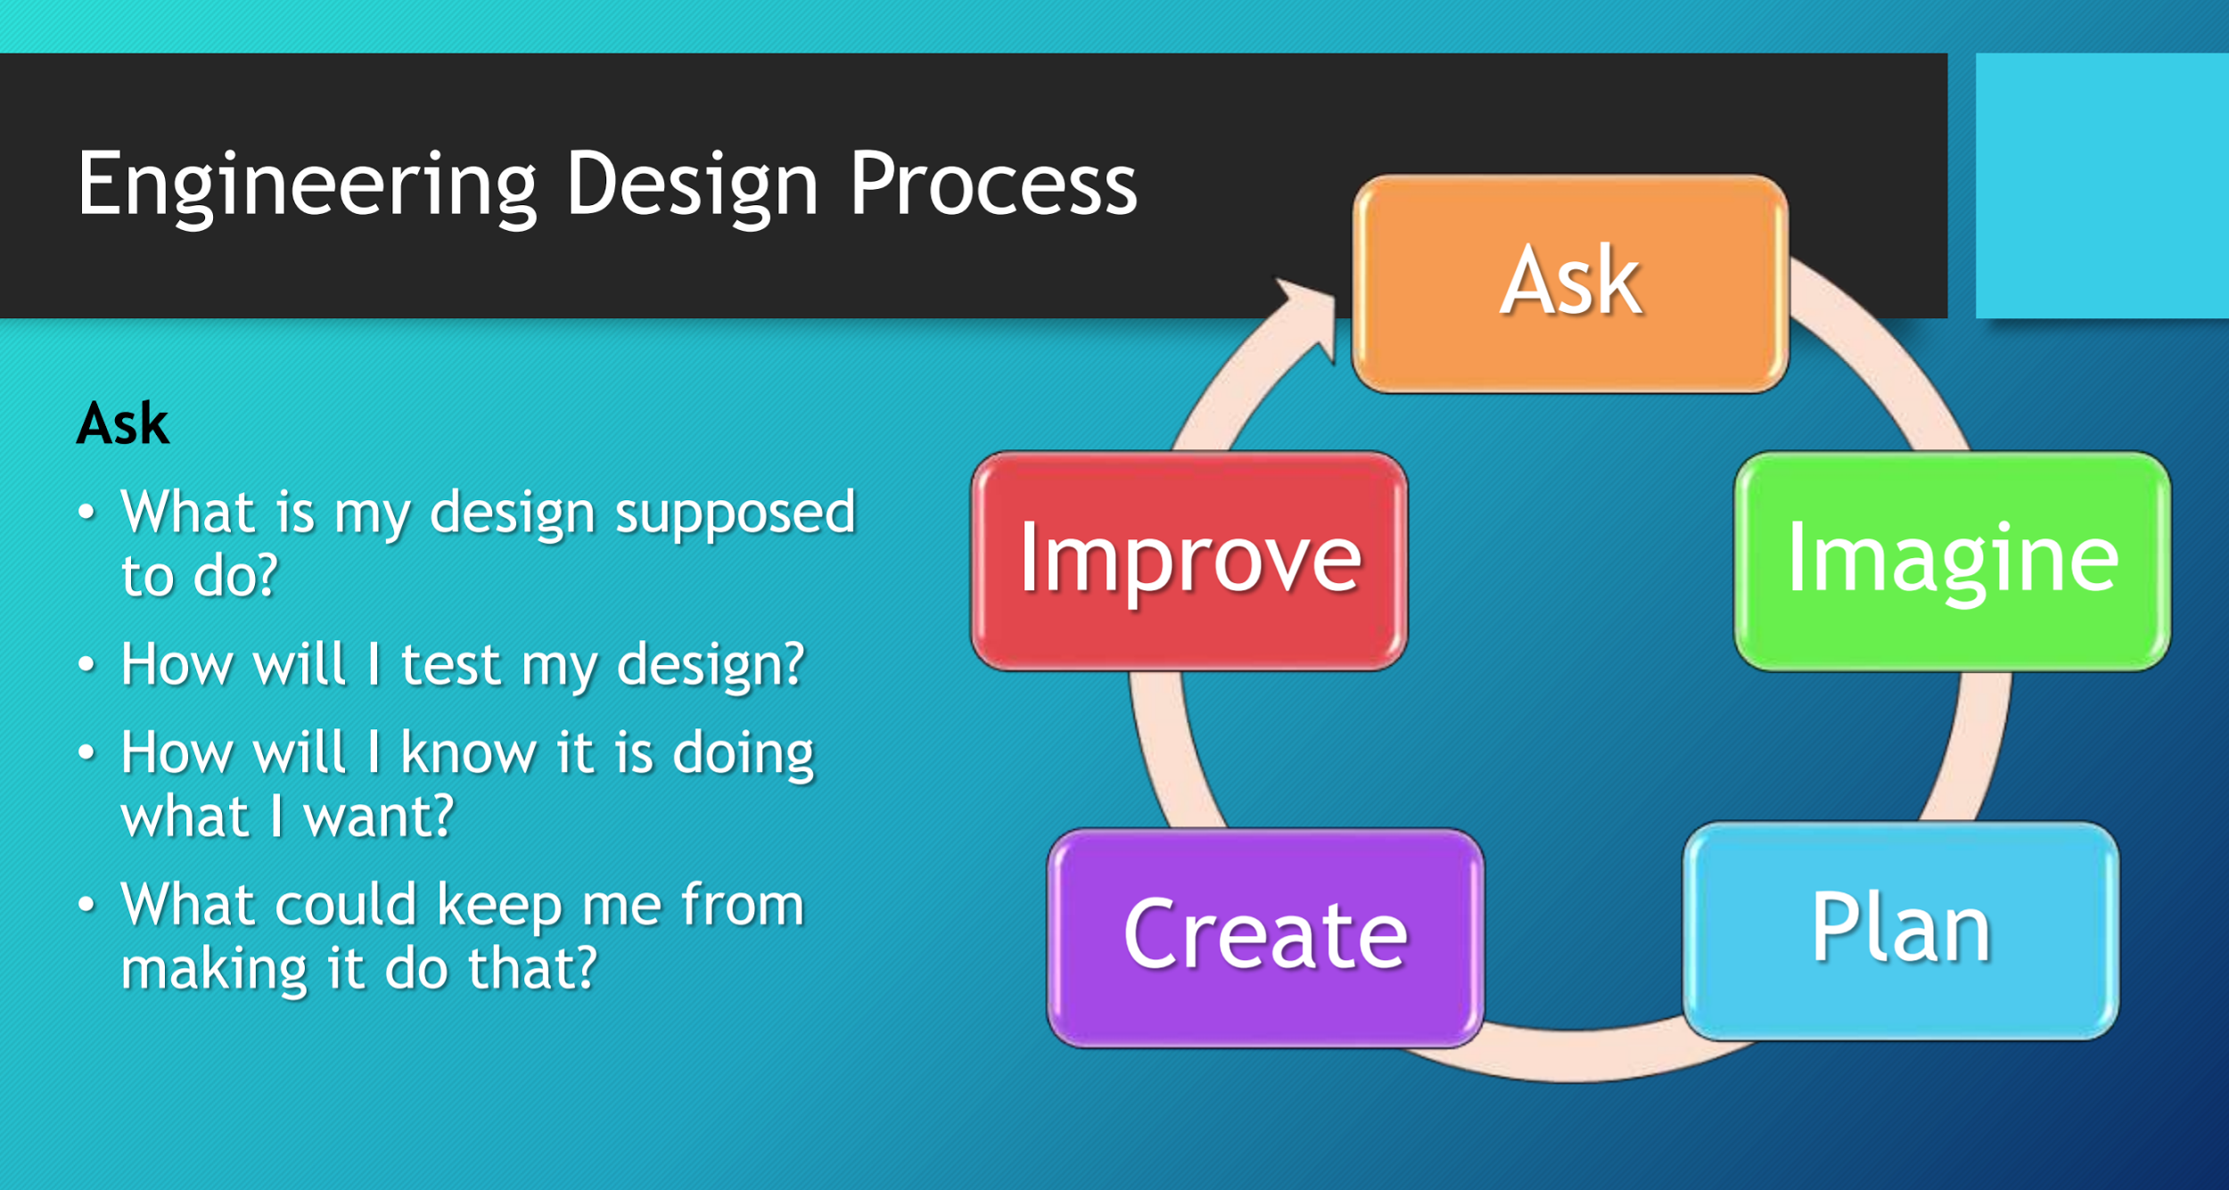

1. What type of robot do you want to build?
2. What type of wheels?
3. How do you want to support the wheels?
4. Will you use sensors for navigation?
5. What sensors do you want to use?
6. Will you use a starter jig or line following?
7. How will you attach attachments?
8. How will you power attachments?
9. Can you use gears?
10. What are the goals for the robot? (e.g. consistent, fast, strong)